Deep Roots Music Festival Survey
Thank you for being part of the 14th annual Deep Roots Music Festival.
All information is for Festival use only and will help improve our festival in the years to come.

- Is this your first time at Deep Roots? Yes No

- How did you hear about Deep Roots Music Festival? (Choose all that apply)
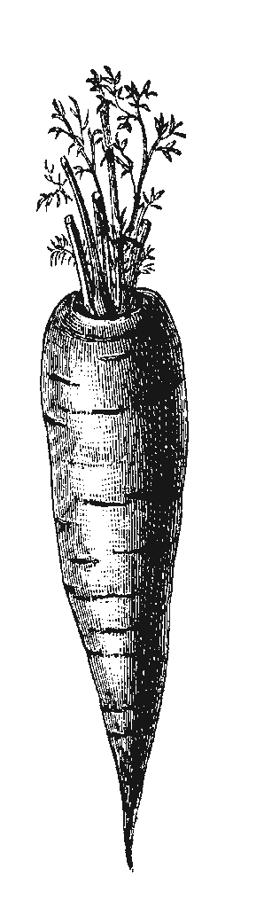
  - ❍ Word of mouth
  - ❍ Advertising (posters)
  - ❍ Radio
  - ❍ Internet
  - ❍ Newspaper or news source
  - ❍ Flyers / Handbills
  - ❍ Social media
  - ❍ TV
  - Other: _____________________________________________________________________

- How many events at this festival did you attend (or do you plan to attend)?

  - Only one
  - More than one
  - I have a Festival pass

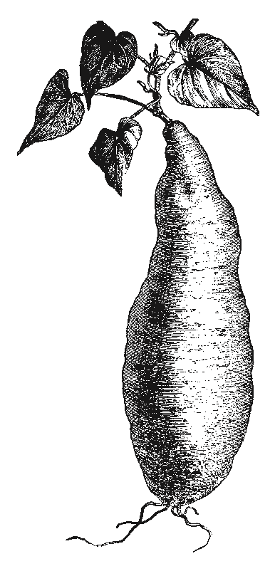
On a scale of 1 to 10 (where 1 = not satisfied; 10 = fully satisfied), how does Deep Roots Music Festival fare in terms of:

- The Venues / Sites for the shows
1 2 3 4 5 6 7 8 9 10
- The process to purchase tickets
1 2 3 4 5 6 7 8 9 10
- Collaboration among performers
1 2 3 4 5 6 7 8 9 10
- Nova Scotia artists
1 2 3 4 5 6 7 8 9 10
- Canadian artists
1 2 3 4 5 6 7 8 9 10
- Family friendly
1 2 3 4 5 6 7 8 9 10

- Can you list some of the event sponsors? _____________________________________________ ________________________________________________________________________________
- Which artist(s) drew you to Deep Roots?______________________________________________

- Which artist(s) surprised you the most? ______________________________________________

_________________________________________________________________________________
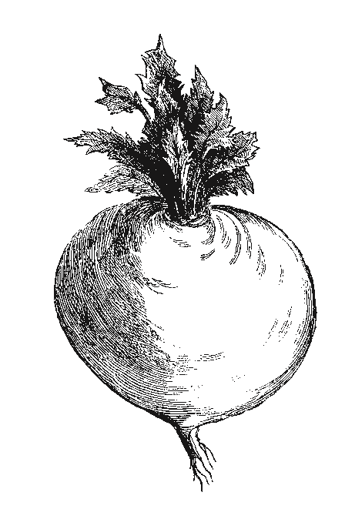
- What is your age? ______________________
- What is your postal code / zip code? __________________________
- Do you think you will come to Deep Roots next year? Yes No

- If no, why not? ___________________________________________________________________

_________________________________________________________________________________
- Can you share your big or small idea to make the festival better?
_________________________________________________________________________________
_________________________________________________________________________________
_________________________________________________________________________________
18. If you are from outside the Wolfville area (more than a 20 minute drive), did you come here specifically for the Festival? Yes No

19. Will you be dining out while in the Valley? Yes No If yes, how many times? ______

20. Will you be shopping while in the Valley? Yes No

21. Will you be staying at a motel, hotel, or B&B? Yes No

THANKS FOR YOUR INPUT! Fill in your name below to be entered in a draw for a 2018 Festival pass.

Name: ______________________________________________________________

Email:________________________________________________ Phone #: ( _____ ) ______ - __________
❍ I would like to receive the Deep Roots news email for updates about the festival and other musical events.
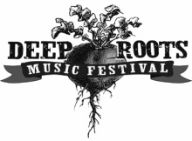
Thank you again for joining us in the Deep Roots Music Cooperative’s celebration of our musical and cultural roots. We hope to see you again next year.

